ACCESS of
Wilmington

Eliminating Barriers. Creating Community.

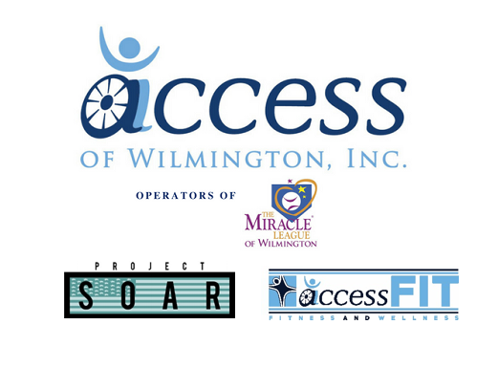
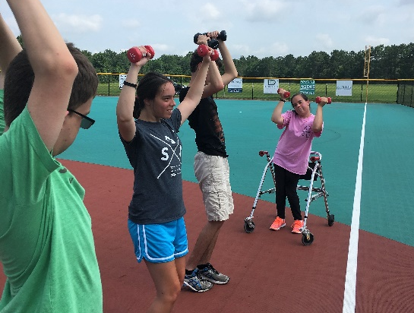
Building community for children, adults, and veterans with disabilities by eliminating barriers to health and wellness through adapted sports, recreation and fitness.

Volunteer Handbook

2021 Corporate Drive, Wilmington, NC 28405 | 910.508.6788 | www.accessilm.org

Table of Contents
Volunteer Handbook
ACCESS of Wilmington
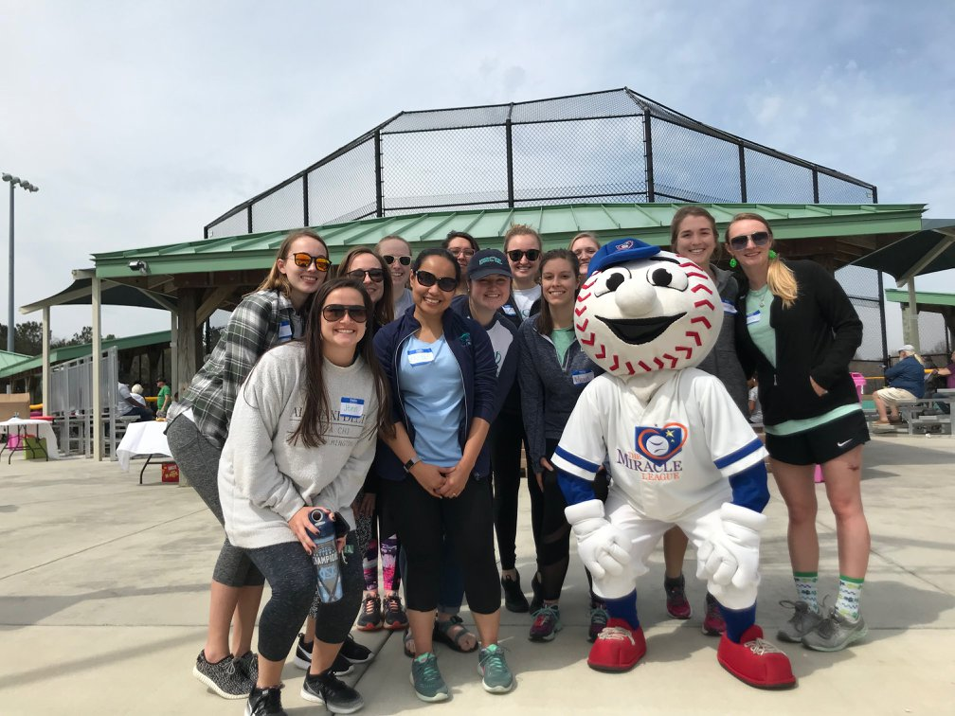

Welcome...............................................................................................  Mission, Values, and Vision.....................................................................  Organizational Staff................................................................................  Our Programs .......................................................................................  Volunteer Job Opportunities..................................................................  Standards and Guideline ......................................................................  Forms  Permission to Perform Background Check..............................................  Volunteer Medical Release Form.............................................................  Volunteer Confidentiality Agreement.....................................................  Agency-Volunteer Agreement...............................................................  Buddy Contract .....................................................................................  Receipt and Acknowledgement of Volunteer Handbook ...................... | 3  4  5  6  7  9  17  18  19  20  21  22

Welcome
Volunteer Handbook
ACCESS of Wilmington

Dear Friend of ACCESS of Wilmington,

Welcome and thank you for joining the ACCESS of Wilmington team!

We are excited that you have chosen to give back to your community through serving children, adults, and veterans living with physical, intellectual, and invisible disabilities, and their families! Thank you for joining ACCESS in eliminating barriers to sports and recreation, and creating community through a commitment to Joy, Inclusion, Love, Acceptance, and fostering Miracles.

What we do would not be possible without the generosity of our volunteers. Thank you for allowing ACCESS to provide opportunities for sports, recreation, and physical activity to children, adults, and veterans living with disabilities across southeastern North Carolina! We are thrilled to have you ACCESS as we strive to achieve our mission each day.

We have outlined our policies and procedures, and included all paperwork that will need to be completed prior to your volunteer experience at ACCESS. Please carefully review the following information and fill out all paperwork prior to orientation. It is our goal to provide you with an outstanding volunteer experience while keeping our mission at the heart of all we do!

Gratefully,
Hayley Sink
Executive Director
Mission, Values, and Vision
Volunteer Handbook
ACCESS of Wilmington

Values
Relationships
Trust
Quality
Innovation
Acceptance
Accessibility
History

Accessible Coastal Carolina Events, Sports, and Services, Inc. is a 501(c)(3) nonprofit organization created in 2008 for the purpose of raising funds to construct The Miracle Field and Playground at Olsen Park in Wilmington, NC.

Since 2013, hundreds of children and adults living with cerebral palsy, Down syndrome, autism, and other physical, intellectual, and invisible disabilities have utilized the 33,000 square foot rubberized BRAX Stadium PPD Miracle Field. In addition to being physically active, ACCESS participants build confidence, skills, and develop lasting relationships. A countless number of families have visited the Kiwanis Miracle Playground, the largest wheelchair accessible playground in North Carolina, which has become a benchmark for accessible playgrounds across the region.

In addition to Miracle League baseball, ACCESS of Wilmington is increasing opportunities for veterans with physical and invisible disabilities through Project SOAR, a collaborative initiative with the University of North Carolina Wilmington funded by the Department of Veterans Affairs. ACCESS also has a signature fitness and wellness program, ACCESS Fit, designed for young adults, adults, and older adults with physical and intellectual disabilities living in our community, as well as those in rehabilitation and care facilities. The ACCESS Fit program has significantly affected the health of participants, and continues to grow each year.
Our Mission is building community for children, adults, and veterans with disabilities by eliminating barriers to health and wellness through adapted sports, recreation and fitness.
Vision
Eliminate barriers and create inclusive community for thousands of individuals living with disabilities in southeastern North Carolina and their families.
Organizational Staff
Volunteer Handbook
ACCESS of Wilmington

Board of Directors
- Chad Porter - Chair
- Zane Bennett - Vice Chair
- Amy Queen - Secretary
- Craig Kelly – Treasurer
- Dan Johnson, Founder & Chair Emeritus
- Adam Keen
- Laura Kay Berry
- Ray Charfauros
- John McLean
- Amanda Taylor
- Stephanie Mayew
- Amanda Taylor
- Corey Barnhill
- Cathy Barlow
- Benjamin Baldwin
- Zane Bennett

Emeritus Directors
- Dr. Dan Johnson, Founder
- David Morrison
- Tammy Pruden
- Michael Franklin
- L.S. “Bo” Dean

Office and Mailing Address

2021 Corporate Drive

Suite B

Wilmington, NC 28405

Miracle Field of Wilmington Address

5510 Olsen Park Lane

Wilmington, NC 28405
Miaya Alston, BS
Program Coordinator – ACCESS Fit and Miracle League
miaya@accessilm.org | 910.398.2211

Staff
Hayley Sink, MPA
Executive Director

hayley@accessilm.org | 910.508.6788

Our Programs
Volunteer Handbook
ACCESS of Wilmington

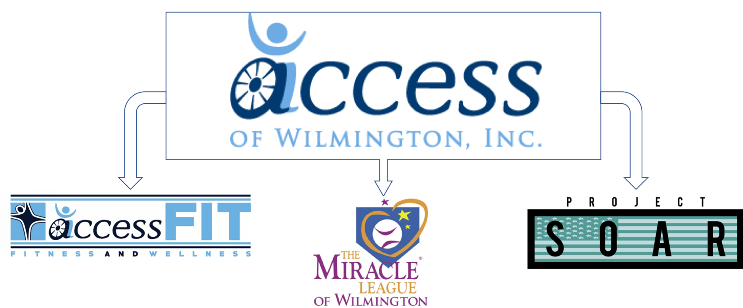
ACCESS Fit | The Miracle League of Wilmington | Project SOAR
- A year-round fitness and wellness program designed for young adults, adults, and older adults living with disabilities; Ages 12+  - ACCESS Fit features an adapted group exercise class, at the Miracle Field.  - ACCESS Fit is held for 12-weeks during the Spring, Fall, and Summer with 8 classes currently offered weekly.  - Other opportunities include: Hotwheels Electric Wheelchair Hockey Team, Kayaking, Archery, Cycling, and Surfing! | - The Miracle League of Wilmington is an accessible baseball league filled with joy, dancing, and homeruns for children and adults living with disabilities; Ages 3+  - The League has 6 Non-Competitive Teams, 2 Competitive Teams, and 2 Tee Ball Teams. All games are played at the Miracle Field.  - The Miracle League of Wilmington hosts a Spring and Fall Season for 8 weeks with games on Saturdays. A Summer Season begins in June with Night Games. | - Adapted sport program offering archery, cycling, golf, kayaking, SCUBA, and surfing for veterans and active members of the Armed Forces living with service-connected illness or injury.  - The mission of Project SOAR is to promote active sport participation among veterans and active members of the Armed Forces living with disabilities to increase their health, wellness, and quality of life.  - Presented by ACCESS of Wilmington in partnership with the University of North Carolina Wilmington.

Miracle League
Volunteer Job Opportunities
Volunteer Handbook
ACCESS of Wilmington

Buddy
Buddies experience the love, joy, and celebration at the Miracle League of Wilmington by assisting children and adults living with physical and intellectual disabilities.

Coach
Coaches are experienced volunteers who take a leadership role during games of their team of All Stars and their volunteer Buddies.

Pitcher
Pitchers help get the game started by throwing the ball to our players.

Catcher
Catchers are responsible for standing behind the plate and catching the ball.

Homer Costume
Have you ever wanted to be a mascot? Now is your opportunity! Be Homer the Miracle League Mascot for game days.

play Program Support Specialist
The Program Support Specialist will assist the Program Coordinator in creating and implementing an adaptive sports program including Archery, Kayaking, movie nights, and other plAy programing.

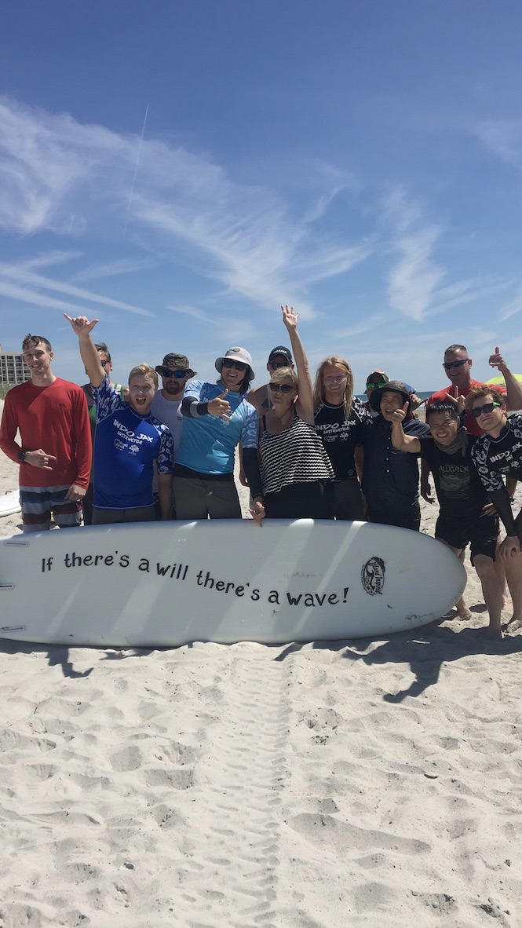
Project SOAR
Volunteer Job Opportunities
Volunteer Handbook
ACCESS of Wilmington

Program Support Specialist

- The program support specialist will assist the Program Coordinator in creating and implementing an adaptive sport programs for veterans living with disabilities.

ACCESS Fit
Volunteer Job Opportunities
Volunteer Handbook
ACCESS of Wilmington

ACCESS Fit Buddy
- The ACCESS Fit Buddy will assist the Program Coordinator in creating and implementing an adaptive exercise program for young adults, adults and older adults with physical and intellectual disabilities.

Standards and Guidelines
Volunteer Handbook
ACCESS of Wilmington

Application Procedure

All volunteers are required to complete a volunteer application.

Applications are completed online through our website at www.accessilm.org/volunteer. A paper application is available by request. All information will be kept confidential, and records will only be made available to other agencies or organizations upon receipt of written authorization as required by legal process. Coaches and Program Support Specialists will also complete an interview with the Program Coordinator prior to their volunteer experience. References will be contacted by the Program Coordinator. Volunteers will be contacted with an offer based on their skills and abilities as well as consideration by ACCESS of Wilmington's staff for what will be the best fit for both the volunteer and our organization. Prior to volunteering, the volunteer must complete all necessary paperwork and attend the required volunteer orientation.

Equal Opportunity

ACCESS of Wilmington is an equal opportunity organization. The established policy of the organization is to affirm and dedicate itself to the primary principle of non-discrimination in all phases of its activities. Volunteer decisions, on all matters including recruitment and selection shall be made solely on merit, on a non-discriminatory basis. Neither shall the organization tolerate harassment of any form to its volunteers or staff. It is expected that all management and supervisory personnel will provide leadership in support of this policy.

Whistleblower Policy

ACCESS requires volunteers and staff to observe high standards and personal ethics in the conduct of their duties and responsibilities. Employees and representatives of the organization must practice honesty and integrity in fulfilling their responsibilities and comply with all applicable laws and regulations. Each volunteer and staff of ACCESS has an obligation to report in accordance with this Whistleblower Policy (a) questionable or improper financial issues (including accounting or auditing matters), and (b) instances where one has a good faith basis to believe that employees and representatives of the ACCESS of Wilmington did not practice honest and integrity or engage in inappropriate behavior contrary to the mission of the ACCESS of Wilmington or violated any applicable laws and regulations. The Whistleblower Policy is intended to encourage and enable Board Members, ongoing volunteers, and employees to raise concerns within the ambit of this policy for investigation and appropriate action. With this goal in mind, no Board Member, ongoing volunteer, or employee, who, in good faith, reports a concern shall be subject to retaliation or, in case of and employee, adverse consequences. Board members and other volunteers should submit concerns directly to the Executive Director.

Orientation and Training

Volunteer orientation is required for all volunteers prior to their volunteer experience. Volunteers will be contacted with orientation specifics after being accepted to the volunteer program. All orientations will be held at the Miracle Field of Wilmington, unless otherwise stated, will review an introduction to the mission, programs, and staff of ACCESS, the role of the volunteer, general policies and procedures, as well as a tour of the facility. Additional training may be required.

Returning volunteers will be required to attend a returning volunteer orientation once a year in order to stay up to date with the changes and growth at Access of Wilmington.

Probationary Period

All regular, non-episodic volunteers will be placed on a 30-day probationary period. At the end of this period the Program Coordinator will follow up with the volunteer to have a mutual conversation about how their volunteer experience at ACCESS of Wilmington has been. The conversation will review volunteer performance to date, determine if the assigned volunteer position is a best fit, and will give the volunteer the opportunity to provide feedback.

Code of Conduct

As a representative of ACCESS of Wilmington we expect all volunteers to hold themselves to the highest professional and moral standards. Each volunteer represents the ACCESS organization in the community, and most importantly serves as a role model to our participants. It is an expectation of all staff and volunteers to be committed to our values of Joy, Inclusion, Love, Acceptance, Community, and fostering Miracles; while creating an environment where barriers are eliminated and community is built. There is a zero tolerance policy for violence, harassment, and illegal activity of any kind, including: immoral or indecent conduct, the use of foul or offensive language on site, physical altercation or any aggressive action; disruptive conduct including: gambling, fighting, horseplay, coercion, intimidation or threats against staff, volunteers, participants or families.

Receiving or Giving Gifts

Volunteers are encouraged not to accept merchandise, entertainment, hospitality, transportation, loan or other tangible or intangible benefit from ACCESS of Wilmington participants or their families without paying the fair market value, unless permission is given by the Executive Director. Volunteers are asked not to provide financial assistance, gifts, personal loans or other benefits to ACCESS of Wilmington participants or their families.

Participant Transportation
Volunteers are not permitted to use personal vehicles to transport participants.

Dress Code

All staff and volunteers are expected to dress professionally and appropriately, looking the part of a role model and leader for the program or event they are working. Volunteers are encouraged to dress comfortably and wear attire that is discrete and non-revealing. Sandal are allowed, but athletic shoes are encouraged.

Clothing with any mention of illegal or illicit activity is strictly prohibited. Name tags will be provided by ACCESS of Wilmington and should be worn at all times.

Technology and Social Media

In an effort to create the best possible experience for our participants, volunteers are expected to keep use of personal cell phones to a minimum during their shifts. Usage includes phone calls, texting, emailing, and general usage.

When using social media, please remember that under no circumstance should anything that you post disclose the identity of any child or family that ACCESS of Wilmington serves. We maintain complete confidentiality of our participants at all times. If any of our participants request to “add” you on any of these social media sites we strongly encourage you to not accept the request so you can keep your personal life private. It is important for you to be a role model for our participants and maintain the code of conduct at all times, including what you make visible on social media sites.

Usage of Agency Equipment/Facilities

Volunteers are prohibited from using any agency equipment, supplies, or facilities for any reason not related to the mission of ACCESS of Wilmington. The McKenzie Picnic Shelter and Miracle Field may be reserved through ACCESS of Wilmington for outside events and activities.

Personal Property

ACCESS of Wilmington cannot be responsible for the loss or theft of personal funds or belongings, nor is it covered by insurance for such loss. Therefore, it is the responsibility of each volunteer to adequately safeguard personal belongings.

Drugs, Weapons, and Alcohol Policy

There is a zero tolerance policy of drugs, weapons, tobacco, and alcohol on the premises of the Miracle Field of Wilmington or ACCESS of Wilmington office. This policy includes the possession or use of any of the above while volunteering, as well as coming to volunteer under the influence of any mind-altering substance.

Attendance Policy

Volunteers are an integral part of ACCESS of Wilmington. Therefore, we ask volunteers be present and on time for their shifts. If they are unable to make it due to unforeseen circumstances, we ask that they notify the Program Coordinator immediately and attempt to find a replacement for their shift. Additionally, if a volunteer foresees that they are going to be late to a shift they must notify the Program Coordinator of their anticipated time of arrival.

In the event of an area-wide emergency, weather related or otherwise, please visit our website at www.accessilm.org or call 910.508.6788 for information regarding your volunteer shift. The safety of our volunteers is very important to us. Please use your discretion when coming to volunteer in inclement conditions.

Confidentiality & HIPPA Requirements

Volunteers are expected to keep all information regarding ACCESS participants, their diagnoses, and their families strictly confidential. ACCESS of Wilmington follows all regulations enforced by the Office for Civil Rights under the HIPPA Privacy Rule to protect the privacy of individuals based on identifiable health information. All documents, paper or electronic, containing any personal information about our participants, families, donors, volunteers, or staff are to remain confidential at all times.

If ever approached by the media for information regarding ACCESS of Wilmington, please immediately refer them to the Executive Director.

Conflicts of Interest

No volunteer should engage in any activity that would undesirably represent ACCESS of Wilmington. Undesirable activities include anything that would reflect negatively of the values and code of conduct expectations set forth by ACCESS of Wilmington. Activities include, but are not limited to, business that impacts the volunteer’s ability to perform their responsibilities, business that utilizes facilities and property of ACCESS of Wilmington, without properly reserving the facilities or equipment, or business that requires a breach of confidentiality.

If you are ever unsure if you are engaging in activities that may be considered a conflict of interest, please contact the Executive Director or Program Coordinator.

Benefits

All volunteers will gain valuable knowledge and experience working with children and adults with disabilities. We welcome students interested in internships or service-learning experiences. All volunteers will receive snacks and/or a meal (when applicable) during their shift. Additionally, volunteers connect with others in our community with similar interests.

Performance Review

All regular, non-episodic volunteers are entitled to an annual performance review where they will meet with the respective Program Coordinator to discuss their experience at ACCESS of Wilmington and provide feedback of the organization. This is a mutual conversation to be certain that you are getting the volunteer experience you desire while giving insight so we can constantly improve our organization to best achieve our mission.

Records

All volunteer records will be kept on file during volunteer service and up to 7 years following the end of volunteer service to ACCESS of Wilmington. Records include: contact information, application and annual reviews, trainings, volunteer positions held, hours volunteered, and any forms signed by the volunteer.

Grievance Procedure

ACCESS of Wilmington reserves the right to reassign, suspend, or terminate volunteers from their service at any time and for any reason at the discretion of the organization. You will be given no less than 24-hour notice prior to your next volunteer shift.
Abuse, Sexual Abuse, and Neglect Prevention Policy
Volunteer Handbook
ACCESS of Wilmington

INTRODUCTION
ACCESS of Wilmington (ACCESS), its employees, volunteers, participants, participant families and related entities (Programs: ACCESS Fit, Project SOAR, and Miracle League), and partners, are committed to building and maintaining a community free of emotional, physical, and sexual misconduct that encourages and fosters appropriate conduct among all persons and respect for individual values.
ACCESS is committed to enforcing the subsequent Abuse, Sexual Abuse, and Neglect Prevention Policy to create an environment free of emotional, physical, and sexual misconduct.
Federal law authorizes ACCESS to address the risk of emotional, physical, and sexual abuse of youth participants. See Protecting Young Victims from Sexual Abuse and Safe Sport Authorization Act of 2017 and Factsheet.
Prevention Training
Federal law authorizes ACCESS to develop training to prevent abuse, including emotional, physical, and sexual abuse, of any youth participant. At a minimum, ACCESS must offer and give consistent training related to the prevention of child abuse to: (1) adult members who are in regular contact with amateur athletes who are minors and (2) subject to parental consent, to members who are minors.
Prevention Policies
Federal law also authorizes ACCESS to develop policies and procedures for implementation to prevent abuse, including emotional, physical, and sexual abuse, of any youth participant. As a part of these policies and procedures, ACCESS must continue to implement reasonable procedures to limit one-on-one interactions between an amateur athlete who is a minor and an adult (who is not the minor’s legal guardian) at an amateur sport facility without being in an observable and interruptible distance from another adult, except under emergency circumstances.
APPLICATION and IMPLEMENTATION
ACCESS of Wilmington is required to follow these Minor Athlete Abuse Prevention Policies, including implementing and monitoring compliance with these policies.
The policies and procedures set forth herein are published by ACCESS in meeting the organization obligations under federal law. ACCESS shall also extend the federal law, and the policies and procedures established by the organization herein, to address the risk of emotional, physical, and sexual abuse of disabled or elder adult participants due to this population being widely served by ACCESS of Wilmington.
Note: Where the Act states “child abuse” and/or “minor or amateur athletes” as “covered individuals,” in the new legislation – ACCESS states this language extends to disabled or elder adults for purposes of organizational coverage.
PROTECTING YOUNG VICTIMS FROM SEXUAL ABUSE and SAFE SPORT AUTHORIZATION ACT of 2017
- The bill amends the Victims of Child Abuse Act of 1990 to extend the duty to report suspected child abuse, including sexual abuse, within 24 hours to all adults who are authorized to interact with minor or amateur athletes by a national governing body, a member of a national governing body, or an amateur sports organization that participates in interstate or international amateur athletic competition. These individuals are called “covered individuals” in the new legislation.
- Child abuse is defined as physical or mental injury, sexual abuse or exploitation, or negligent treatment of a child.
- Per current federal regulations, reports of child abuse should be made to the local law enforcement agency or local child protective services agency that has jurisdiction to investigate reports of child abuse or to protect child abuse victims or to the FBI. These regulations have not yet been updated to reflect the recent change in the law. Until such time as the regulations are updated, ACCESS will make reports to (1) local law enforcement where any alleged incident took place to the extent it can be determined and the incident occurred in the United States, (2) local law enforcement where the victim resides if different than (1), and (3) the Director of the County Department of Social Services as mandated by the State of North Carolina, in which ACCESS operates within.
- An individual who is required, but fails, to report suspected child sexual abuse is subject to criminal penalties including fines and up to one (1) year in jail.
These obligations are in addition to the following State of North Carolina law requirements:
- North Carolina citizens have a legal duty to report in cases where there is suspected:
  - Child abuse and/or neglect by a parent, guardian, custodian or caretaker.
  - Abuse, neglect or exploitation of a disabled or elder adult by their caretaker.
ACCESS of Wilmington references NC Chapter 7B-Juvenille Code as it defines abuse, neglect, and dependency of those less than 18 years of age, and NC Statute 14-32.3 as it defines domestic abuse, neglect, and exploitation of disabled or elder adults 18 years of age or older.
REPORTING PROCEDURE
ACCESS of Wilmington is committed to compliance with the state and federal legal requirements for reporting allegations or incidents of abuse, sexual abuse, misconduct and/or neglect to the appropriate law enforcement and protective services organizations.
In compliance with federal and state law, employees and volunteers must report disclosure or suspicion of abuse, including sexual abuse, and/or neglect to the Executive Director or Program Coordinator on site immediately. Additionally, any injury of a child, adult, or volunteer must be reported to the Executive Director or Program Coordinator on site immediately. Do not directly confront the individual(s) that are the source of the report or discuss the disclosure outside of confidential resources provided to you as a mandatory reporter. All necessary paperwork must be completed and submitted to the Executive Director within 24-hours of the disclosure or injury.
The Executive Director will promptly report the allegation to proper law enforcement authorities or protective service organizations.
Per current federal and state regulations, the Executive Director will promptly report the allegation to the local law enforcement agency or local child or adult protective services agency that has jurisdiction to investigate reports of child abuse or to protect child abuse victims or to the FBI. These regulations have not yet been updated to reflect the recent change in the law. Until such time as the regulations are updated, ACCESS will make reports to (1) local law enforcement where any alleged incident took place to the extent it can be determined and the incident occurred in the United States, (2) local law enforcement where the victim resides if different than (1), and (3) the Director of the County Department of Social Services as mandated by the State of North Carolina, in which ACCESS operates within.
It is the policy of ACCESS of Wilmington not to attempt to investigate or assess the validity or credibility of an allegation of sexual or physical abuse before reporting the allegation to proper law enforcement authorities or protective services organizations.
Any an emergency, please contact 911. However, if you make a report of child or disabled adult or elder abuse to law enforcement, please also communicate this report to the ACCESS of Wilmington Executive Director immediately.
If you have any questions, you can contact Hayley Sink at hayley@accessilm.org or 910-508-6788.
PREVENTATIVE ACTION
Policy for Supervision of Participants
ACCESS of Wilmington takes every effort to provide a safe environment for all participants. Per ACCESS staff and volunteer policy, no employee or volunteer should ever be isolated, out of line-of-sight from others, with a youth or adult participant at any time. At a minimum, even in emergency situations, ACCESS strives to have two (2) adult staff and/or volunteers with a participant. The purpose of this policy is to avoid one-on-one interactions between adults and youth and vulnerable adult participants that are not easily observable by others. If individual meetings with a youth or vulnerable adult participant must be held in an office, keep the door open and make certain another adult staff or volunteer is present in the office and put on notice of the meeting. Closed door meetings should not occur with any participants.
Furthermore, a parent and/or guardian is required to be present at all ACCESS of Wilmington programs. Therefore, staff and volunteers, should not need to assist with personal care, medical needs, and/or toileting. Staff and volunteers should instead locate the participant’s parent and/or guardian who will then assist the participant.
Employee and Volunteer Screening and Selection
As part of the prevention program, ACCESS is committed to maintaining a screening program for prospective and existing employees, board members, and other volunteers of ACCESS of Wilmington. The organization may utilize a variety of methods of screening and selection, including but not limited to applications, personal interviews, criminal background checks, and personal and/or professional references.
Adult (18 years of age or older) Employee and Volunteer Application Process:
- All volunteers must complete the ACCESS of Wilmington Volunteer Application, available both online and in print.
- All employees and board members must undergo background and sex offender registry checks. Additionally, volunteers that are in a coach, leadership, or regular, non-episodic volunteer role, or any volunteer that discloses a “yes” response under the Background Section of the ACCESS Volunteer Application must also undergo background and sex offender registry checks.
Automatic disqualifiers include, but are not limited to:
- Conviction of a felony crime,
- Conviction of an identity theft or related crime,
- Conviction of a Class 1 misdemeanor crime against another person or similar crime with a special penalty structure, excluding minor traffic offenses, within the past ten (10) years,
- Conviction of a Class 1 misdemeanor crime not against another person or similar crime with a special penalty structure of moral turpitude (lying, cheating, stealing) within the past five (5) years,
- Conviction of multiple Class 1 misdemeanor crimes not against another person or similar crime with a special penalty structure, excluding minor traffic offenses, within the past five (5) years,
- Conviction of a Class 1 misdemeanor crime not against another person or similar crime with a special penalty structure, excluding minor traffic offenses, within the past year,
- Standing or active protective orders,
- Adverse judgment for damages or civil penalty involving sexual or physical abuse.
Staff and Volunteer Training
ACCESS of Wilmington staff and volunteers, regular and episodic, that will be interacting with youth, disabled, or elder adult participants must attend Volunteer Orientation held by ACCESS of Wilmington and will receive preventative training through Abuse Prevention Systems’ Awareness Training: A live and online instruction and testing to recognize abuse and abuser behaviors.
INVESTIGATION and FOLLOW UP
ACCESS of Wilmington will take all allegations of sexual abuse or misconduct seriously and will promptly, thoroughly, and equitably investigate whether misconduct has taken place. The organization may utilize an outside third-party to conduct an investigation of misconduct.
ACCESS will cooperate fully with any investigation conducted by law enforcement or other regulatory and/or protective services agencies. ACCESS will make every reasonable effort to keep the matters involved in the allegation as confidential as possible while still allowing for a prompt and thorough investigation.
Anti-Retaliation and False Allegations
ACCESS of Wilmington prohibits retaliation made against any employee, volunteer, board member or other person who lodges a good faith complaint of sexual abuse or misconduct or who participates in any related investigation.
Making knowingly false or malicious accusations of sexual abuse or misconduct can have serious consequences for those who are wrongly accused. ACCESS of Wilmington prohibits making false or malicious sexual misconduct allegations, as well as deliberately providing false information during an investigation. Anyone who violates this rule is subject to disciplinary action, up to and including termination of employment or membership and criminal prosecution.

Permission to Perform Background Check
Volunteer Handbook
ACCESS of Wilmington

I permit ACCESS of Wilmington to perform a background check of the following:

- Criminal Record
- Driving Record
- Employment History
- Volunteer History
- Finances
- Educational Status
- Personal References
- Medical Records

and any other sources that are appropriate for the volunteer position I desire.

I understand that I do not have to submit to the background check, but failure to do so may exclude me from consideration for my desired volunteer position.

I understand that only information that is necessary in determining my suitability for the volunteer position I desire will be collected. I understand all information collected will be kept confidential.

I give permission for all necessary individuals and organizations to be contacted for this background check. I permit all providers to give their complete and honest opinion of my ability to succeed in this volunteer position and to give any additional information they deem relevant.

Volunteer Name (Please Print) _____________________________

Volunteer Signature ____________________________________________
Date ________________

Program Coordinator Signature _____________________________________________ Date ________________

Volunteer Medical Release Form
Volunteer Handbook
ACCESS of Wilmington

Volunteer Name _____________________________________________________________

Volunteer Job Title ___________________________________________________________

I have examined and cleared the above individual to volunteer at ACCESS of Wilmington based on the volunteer position description for the volunteer job title listed above. It is my professional opinion that the individual is in good health and will be able to perform the described activities at a satisfactory level, safely, and without limitations.

I agree to contact ACCESS of Wilmington at 910.508.6788 immediately if the individual’s health status changes at any time under my treatment in any way that may cause them to be unable to perform the described activities of their volunteer position at a satisfactory level, safely, and without limitations.

PLEASE ATTACH THE FOLLOWING:

- Current immunization record,
- Negative TB test results,
- A flu shot, where applicable

Physician’s Name (Please Print) ________________________________________________

Physician’s Signature ________________________________________________

Date __________________

Additional Comments:

Volunteer Confidentiality Agreement
Volunteer Handbook
ACCESS of Wilmington
Agency - Volunteer Agreement
Volunteer Handbook
ACCESS of Wilmington

Accessible Coastal Carolina Events Sports and Services, Inc., doing business as ACCESS of Wilmington, is a 501 (c)(3) nonprofit organization with a mission to develop recreational programs and partnerships throughout Southeastern North Carolina to facilitate inclusive activities for individuals with disabilities and their families; thus, positively impacting their health, wellness, and quality of life. All information and disclosures are to be considered confidential in nature.

I hereby understand and agree to the below guidelines of confidentiality:

I understand that as a volunteer I may have access to confidential records and information. I understand that I am expected to keep all information regarding the participants, their diagnoses, and their families strictly confidential.

I understand that ACCESS of Wilmington follows all regulations enforced by the Office for Civil Rights under the HIPPA Privacy Rule and that all documents, paper or electronic, containing any personal information about our participants, families, donors, volunteers, or staff are to remain confidential at all times. Any paper documents containing any personal information (i.e. Miracle League Player Rosters) should be returned to the Program Coordinator prior to leaving the premises.

Sharing of any ACCESS of Wilmington operations, including marketing, finance, fundraising, volunteers, participant information, and any other information, outside of ACCESS of Wilmington, is not permitted.

I agree that if I am ever approached by the media for information regarding ACCESS of Wilmington I am to immediately refer them to the Executive Director.

Volunteer Name (Please Print) __________________________________________________

Volunteer Signature _____________________________________________________________ Date ________________

Program Coordinator Signature _________________________________________________ Date ________________

Agency-Volunteer Agreement
Volunteer Handbook
ACCESS of Wilmington

We, ACCESS of Wilmington, agree to the volunteer services of ______________________________________ starting on _____ /_____ / 20_____. We commit to:

- Provide sufficient materials, training, and guidance for the volunteer to perform their position.
- Open communication with supervisor(s) as an agency and to provide annual performance reviews to evaluate the volunteer on their performance.
- We agree to be receptive of volunteer feedback of the agency during their performance review and throughout their volunteer experience to best achieve our mission.
- Respect the abilities and needs of each volunteer and will do our best to accommodate individual volunteer needs.
- To treat the volunteer as an integral part of our team and a partner in achieving our mission.

I, ________________________________________, agree to serve as an ACCESS volunteer and commit to:

- Perform my volunteer duties to the best of my ability.
- To follow all agency policies and procedures, including confidentiality of agency and participant information.
- To follow the code of conduct and hold myself to these standards as a representative of ACCESS of Wilmington.
- To be present and on time for my shifts. If I am unable to make it, I will notify the Program Coordinator immediately and attempt to find a replacement for my shift.
- To act as an integral part of the team and to take ownership of the mission of ACCESS of Wilmington.

Volunteer Name (Please Print) _______________________________________

Volunteer Signature ____________________________________________________ Date ________________

Program Coordinator Signature _______________________________
Date ________________

BUDDY CONTRACT
I, _____________________________________, agree that as a volunteer Buddy, it is my job to support the mission and purposes of ACCESS of Wilmington and the Miracle League of Wilmington.
- I agree to devote my full attention to the Miracle League player I am paired with.
- My specific duties will include acting as a “Buddy” to the Miracle League players.
Buddy Responsibilities:
- Safety First. Keep an eye out for bats, balls, obstacles, and anything else that may cause an unpleasant experience for your Miracle League player or you.
- Encourage Independence. Ask players if and what they need help with, allowing them to do as much as they can on their own.
- Have Fun! Sing, dance, cheer, encourage, and of course, play baseball!
- Be a Friend! Get to know your player and their family!
- I will report to the volunteer table at the start of each shift and arrive at least 30 minutes prior to the game.
- I will comply with the Miracle League of Wilmington rules set by ACCESS of Wilmington and the Miracle League.
- I understand my specific duties may also include assisting with setup, take-down, concessions, and other duties as specified. All rules are very important to the success of the Miracle League of Wilmington.
- I will be kind, flexible, and understanding when it comes to working with all Miracle League players, their families, staff, and other volunteers to create an incredible experience for all!

Volunteer Signature __________________________________________________ Date __________________________

IT’S SO MUCH MORE THAN BASEBALL!
Receipt and Acknowledgement of Volunteer Handbook
Volunteer Handbook
ACCESS of Wilmington

I have received ACCESS of Wilmington's Volunteer Handbook and acknowledge that I am responsible for knowing all information, policies, and procedures within. I also understand that it is my obligation to honor the code of conduct and follow all policies and procedures within.

I understand that ACCESS of Wilmington reserves the right to amend the Volunteer Handbook at any time and if I have any questions regarding any of the policies and procedures outlined I am to contact the Program Coordinator for clarification.

I understand that if I am unable to follow the policies and procedures set forth by ACCESS of Wilmington and found within the Volunteer Handbook that I am subject to reassignment, suspension, and possible termination.

I understand that volunteering at ACCESS of Wilmington is a privilege. Furthermore, I understand that ACCESS of Wilmington reserves the right to reassign, suspend, or terminate my service at any time and for any reason at the discretion of the organization with no less than 24-hour notice prior to my next volunteer shift.

I agree to contact the Program Coordinator with any questions regarding the contents of the Volunteer Handbook or the above acknowledgement.

Volunteer Name (Please Print) ________________________________________

Volunteer Signature _______________________________________________ Date ________________

Program Coordinator Signature ______________________________
Date ________________

